
SUMMER OUTING
JUNE 16, 2023 @ 12:30PM
Members $10.00 refundable @ door
Guests $20.00
THE LAST RESORT
325 Farnum Pike, Smithfield, RI
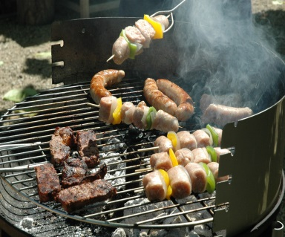
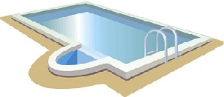
SEE A UNION REPESENTATIVE FOR TICKETS

